

Resource: Making transfer applications to the Koori Court
A Cemino v Cannan resource for advocates and lawyers

The resource is comprised of:
Part 1: A flowchart for assessing whether a proceeding can be transferred under the MC Act
Part 2: Preparing to make an application for transfer to the Koori Court
Part 3: A guide to making an oral application for transfer, including sample oral submissions
Part 4: A short case summary of Cemino v Cannan

The Cemino v Cannan & Ors case considered the cultural rights of Aboriginal Victorians under the Charter in relation to transferring proceedings from the Magistrates’ Court to the Koori Court. The Judge in this case found that the relevant rights under the Charter, including section the right to equality s 8(3), and the cultural rights of Aboriginal Victorians 19(2), were directly applicable to the Magistrate’s Court by reason of section 6(2)(b) of the Charter, which provides that the Charter applies to courts and tribunals to the extent they have certain functions.

Accordingly, courts must consider the distinct cultural rights of Aboriginal people and their right to equality when making decisions in relation to an Aboriginal person’s request to be heard in the Koori Court. This resource will assist lawyers and advocates to assess whether a proceeding can be transferred to the Koori Court under s4F of the Magistrate’s Court Act, and how to do so.

Part 1
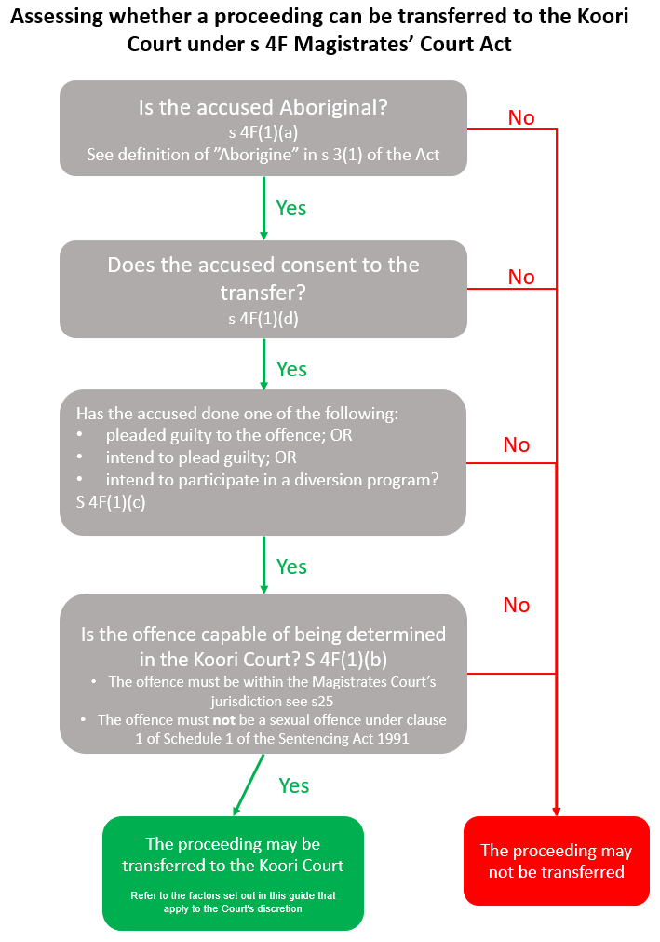

Part 2: Preparing to make an application for transfer to the Koori Court
If you have instructions to make a transfer application, the first thing you should do is check that the requirements in s 4F of the Magistrates’ Court Act are met so that the proceeding can be transferred. Refer to the flowchart in s 4F of the Act.
If the proceeding can be transferred, you will need to do the following:
- Take instructions from the client and get their consent to refer their matter to the Koori Court if the transfer requirements are met.
- Respectfully ask the client about their Aboriginality and explain that proof will be needed by the Court to make the transfer. The Magistrates’ Court Act contains a definition of “Aboriginal” that will need to be met. The Koori Court Officer may ask for a Confirmation of Aboriginality certificate. Ask the client if they can provide evidence (which may be their own oral evidence) of the following three matters:
  - they are a descendant of an Aboriginal or Torres Strait Islander person; and
  - they identify as an Aboriginal or Torres Strait Islander; and
  - are accepted as an Aboriginal or Torres Strait Islander by an Aboriginal or Torres Strait Islander community.
We recommend that you speak with the client and inform them that they can expect questions about their family and their connection to their culture and that they should be prepared to answer these if they wish to have their matter heard in the Koori Court.
- Ensure that the resolution of the charge, including any amendments to the summary, is agreed with the prosecutor. Advise the prosecutor of your intention to adjourn the matter to the Koori Court.
- Speak with the Koori Court coordinator or court registrar. The booking process varies from court to court, but usually involves a brief conversation between the client and the coordinator and the completion of certain forms before a date is provided.
- Make an oral application for the proceeding to be transferred to the Koori Court.

Part 3: Making an oral transfer application to the Koori Court
In most cases, the transfer application will be granted without resistance. In that case, you will only be required to make very brief oral submissions. For example:
This matter has resolved, and my client would like their plea to be heard in the Koori Court. I have filed the relevant paperwork with the coordinator and obtained the date of XXX.
However, if you encounter resistance to the matter being transferred to the Koori Court, from a prosecutor or the magistrate, you may need to do the following:
- Address the Court on why each of the requirements in s 4F of the Act are met. The onus is on the accused to persuade the Court that the transfer should occur.
- Make submissions on why the Court should exercise the discretion to transfer the proceeding to the Koori Court.
We recommend that you bring a copy of Cemino v Cannan [2018] VSC 535 to Court and address the Court on how the Charter is relevant to the transfer decision. Please see the case note in Part 4 below.

Sample Oral Submissions (Detailed)
A sample script for an oral transfer application that may be used if necessary is set out below. It should take you about 10 – 15 mins to make these submissions.
We note these some Magistrates may not require detailed oral submissions. However, we recommend that you are prepared to make full submissions and adjust them if the Magistrate indicates that less detailed submissions are required.
My instructions are to make an application to have the proceeding transferred to the Koori Court Division of the Magistrates’ Court sitting at [insert venue] under s 4F of the Magistrates’ Court Act 1989.
Each of the factors in s 4F of the Act are satisfied in this case. The accused is an Aboriginal person who consents to having the proceeding transferred. [Refer to the proof of Aboriginality and definition in the Act]. They have been charged on summons with [insert offence, eg one count of driving an unregistered motor vehicle on a highway]. The offence is one that can be dealt with by the Koori Court Division.
The Court therefore has a discretion to transfer the proceeding to the Koori Court. The transfer discretion was considered in Cemino v Cannan [2018] VSC 535 (Cemino).
The Supreme Court held (at [69]) that the discretion must be exercised in accordance with the scope, purposes and objects of the Act and the creation of the Koori Court as a specialist Court in Victoria.
The following non-exhaustive list of relevant factors were identified by the Court in Cemino: [Draw attention to the factors that favour transfer in the particular case and be prepared to respond if any factors disfavour transfer:]
  - Transferring the proceeding to the Koori Court will enable the proceeding to be determined in a forum involving greater participation of the Aboriginal community in the sentencing process through the role played by Aboriginal Elders and Respected Persons in the Koori Court
  - Elders and Respected Persons who participate in the Koori Court hearing are likely to be from the same nation as the accused
  - Distance of the Koori Court from the accused’s residence
  - Location of the alleged offences
  - Nature of the offences
  - Prior sentencing of the accused by the Koori Court and the accused’s conduct after the prior sentence.
We draw to your Honour’s attention to s 4F(3) of the Act. It makes clear that if a proceeding is transferred from one venue of the Court to another, the new venue becomes the “proper venue” of the Court. This is important because the Supreme Court in Cemino held that the Magistrate made an error when applying the definition of “proper venue” in the Magistrates Court Act, as interpreted in the case of Rossi v Martland (1994) 75 A Crim R 411. Rossi stands for the proposition that generally serious offences should be dealt with in the locality where they occur, especially when the defendant lives in that locality. In Cemino, the Supreme Court found that the Magistrate made an error in applying the same principle of “proper venue” as when Rossi was decided. The Magistrate gave this view of the “proper venue” emphasis at the exclusion of other relevant matters. It is clear from Cemino that the “proper venue” principle in the Rossi case is not determinative of the decision whether to transfer to the Koori Court.
Further, the Charter of Human Rights and Responsibilities supports the transfer to the Koori Court. The Court’s failure to consider Charter rights was the second ground of error found by the Supreme Court of Victoria in Cemino v Cannan [2018] VSC 535. The Supreme Court held that the right to equality before the law in s 8(3) and Aboriginal cultural rights in s 19(2)(a) of the Charter should be taken into account by the Court when deciding a transfer application.
As the Court accepted in that case (at [154]):
- the protection and promotion of these rights are advanced by the operation of the Koori Court
- Further, the Court stated (at [147]), that the proper exercise of the discretion will affect whether an Aboriginal person has access to the Koori Court, which in turn enables an Aboriginal person to have the benefit of, their identity and culture when they are charged with criminal offences.
In summary, whilst the location of the alleged offences is a relevant matter, it is not the only factor, and not alone determinative. Having regard to the range of relevant factors including the significant Charter rights raised in this application, we submit that it should be transferred to the Koori Court.

Other possible resistance you may face and suggested responses
Resistance | Response
The offending is too serious to be heard in the Koori Court/ offers an easy option | As well as sitting as a division of the Magistrates’ Court, the Koori Court also sits as a division of the County Court, hearing pleas to serious charges with higher maximum penalties than those available in the Magistrates Court.  The Victorian Supreme Court of Appeal has found that actively participating in the Koori Court “sentencing conversation” and Koori Court process is more burdensome than a traditional plea hearing and therefore is a factor that mitigates punishment: R v Morgan [2010] VSCA 15, [33]-[39], [40] and Honeysett v The Queen [2018] VSCA 214, [42]-[55].
The accused has been before the Koori Court before and is back at Court so the process wasn’t effective | The accused’s prior history at the Koori Court is a factor that can be taken into account in the exercise of the discretion: Cemino (see bullet point list above).  But the fact that the accused has been at the Koori Court before shouldn’t be a reason not to transfer this proceeding because:  - whether the accused has been before the Koori Court before does not make them ineligible under s 4F.  - just because the accused has been before the Koori Court before doesn’t mean that the Koori Court process wasn’t effective.  - the fact that the accused has been there is a reason in favour of transfer, as it could lend greater potency to the sentencing conversation because the elders may already know them.
The offending is subject to mandatory licence disqualification or fettered sentencing discretion, so there is “no point” | The benefits of a “sentencing conversation” at the Koori Court with members of the offender’s own community persist regardless of the ultimate disposition.

Further detail on the Charter
The Charter should be taken into account by the Magistrates’ Court when deciding a transfer application. The way that the Charter applies in this context is not through the public authority obligation (in s 38) but by reason of s 6(2)(b) and s 32 of the Charter.
- Section 6(2)(b) of the Charter
Section 6(2)(b) states: “This Charter applies to … (b) courts and tribunals to the extent that they have functions under Part 2 and Division 3 of Part 3 [of the Charter]. “Court” is defined in the Charter to include the Magistrates’ Court.
This section of the Charter has been interpreted by Courts in Victoria to make some Charter rights directly applicable to courts and tribunals. The scope of s 6(2)(b) is still unclear. The current interpretation of this section is known as the “intermediate construction”. It focuses on the function being exercised by the court. Under this construction, the functions of the court under Part 2 of the Charter are those which involve applying or enforcing the Charter rights that relate to court and tribunal proceedings.
It is often challenging to work out what rights apply, and when, under this section. In Cemino, the Supreme Court of Victoria held that the Magistrates’ Court had a limited function under the equality right (s 8(3) and Aboriginal cultural rights (s 19). The limited function under the equality right was the Court’s existing responsibility to ensure people are treated equally and fairly. The Court also found that the Magistrates’ Court had a limited function by reason of the Aboriginal cultural rights protected in the Charter – the Magistrates’ Court was required to exercise the transfer discretion taking into account the purpose, scope and objects of the Magistrates’ Court Act.
- Section 32 of the Charter
In Cemino, the Court also found that s 32(1) of the Charter had a role to play when interpreting the transfer provision in s 4F(2) of the Magistrates’ Court Act. Section 32(1) sets out a statutory interpretation rule. It states: “So far as it is possible to do so consistently with their purpose, all statutory provisions must be interpreted in a way that is compatible with human rights.” The Court held that s 32(1) meant that the Magistrate should have taken into account the right to equality and Aboriginal culture rights when deciding whether to transfer the proceeding. The Court said that the protection and promotion of these rights, in the case of Aboriginal persons involved in criminal proceedings, are advanced by the operation of the Koori Court.

If the application is refused
There may be grounds for judicial review of the Magistrate’s decision to refuse the transfer application. The deadlines for filing an originating motion are strict and you should check the latest version of the Supreme Court Rules for the timeframe. Currently, the proceeding must be commenced within 60 days of the date of the decision: Order 56.02, Supreme Court (General Civil Procedure) Rules 2015. You will need to obtain a transcript of the audio recording for the hearing and seek advice from a lawyer with Charter experience.

Part 4: Case note on Cemino v Cannan [2018]
VSC 535
Facts
- The Magistrates’ Court sitting at Echuca refused an application to transfer criminal proceedings to the Koori Court Division at Shepparton.
- The Magistrates’ Court applied a proper venue principle from a decision pre-dating the establishment of the Koori Court Division, according to which the proper venue is the Court closest to the offending/offender.

Decision
- On judicial review, the Supreme Court of Victoria (Ginnane J) quashed the Magistrates’ Court decision for errors of law on the face of the record. The errors of law were both misapplication of the discretion in s 4F of the Act and a failure to properly apply the Charter of Human Rights and Responsibilities. The proceeding was remitted to a differently constituted Magistrates’ Court for re-determination according to law and the reasons given by the
Supreme Court.

Factors identified that are relevant to the transfer discretion
- The Court stated (at [69]) that the discretion must be exercised in accordance with the scope, purposes and objects of the Magistrates’ Court Act and the creation of the Koori Court as a specialist Court in Victoria
- The following list of non-exhaustive factors were identified by the Court that may be relevant when making a transfer decision (at [73], [143] and [147]:
  - The greater participation of the Aboriginal community in the sentencing process through the role played by Aboriginal Elders and Respected Persons in the Koori Court
  - Whether the Elders and Respected Persons who are likely to participate in the Koori Court hearing are from the same nation as the accused
  - The distance of the Koori Court from the accused’s residence
  - Location of the alleged offences
  - Nature of the offences
  - Prior sentencing of the accused by the Koori Court and the accused’s conduct after the prior sentence
  - Distinct cultural rights of Aboriginal persons to enjoy their identity and culture with other members of their community protected in s 19(2)(a) of the Charter since access to the Koori Court enables an offender to enjoy their identity and culture when they are charged with criminal offences
  - Transferring the proceeding will give effect to the right to equality before the law protected in s 8(3) of the Charter since the Koori Court was established to reduce systemic disadvantage faced by Aboriginal people.
Relevance of the Charter in the transfer decision
- There are two “operative” provisions that make the Charter relevant: s 6(2)(b) and
s 32.
- The Court held that the Magistrate is not acting as a public authority when making a transfer decision ([99]), but Charter rights are relevant in the transfer decision because the Court has a relevant function under the equality rights (s 8(3) and Aboriginal cultural rights (s 19(2)(a)) of the Charter ([144] and [147]). This conclusion was reached because of a provision in the Charter that has been held to make particular Charter rights applicable to Courts and tribunals in the exercise of some of their functions (s 6(2)(b)). This section is explained in Part 3 above.
- Nothing special is required to be done under s 8(3) of the Charter ([146]). Because the Court has a function under s 19(2)(a) of the Charter, the Court needs to consider the content of this right when exercising the transfer discretion ([147]).
“The proper exercise of the discretion will affect whether an Aboriginal person has access to the Koori Court, which in turn enables an Aboriginal person to enjoy, in the sense of having the benefit of, their identity and culture when they are charged with criminal offences. ([147])”
- Second, the Court accepted that the Magistrate was required by reason of s 32 of the Charter to exercise the transfer discretion in s 4F(2) of the Magistrates’ Court Act by taking into account the rights contained in s 8(3) and s 19(2)(a) of the Charter ([154]).
- Although the Charter rights had to be considered by the Magistrates’ Court, the Charter did not require the proceeding to be transferred.

It is recommended that you bring a copy of this case to Court and address the Court on why the Charter is relevant to the transfer decision.

